# **Welcome to Amazon. To complete your IT setup, you need to complete 3 main tasks, in order, AFTER your Day 1 video call with your manager:**

1. Register your security keys.
   * You’ll use your security key daily to access the Amazon network.
2. Set up your computer.
   * Either your personal computer with Amazon WorkSpaces or with an Amazon-issued laptop.
3. Set up your software and tools.

Passwords

To keep Amazon data secure, we use multiple passwords through various steps of the IT setup process. To help you tell them apart, here is a quick reference guide for the different passwords.

* **Amazon password**
  + Your manager will provide your temporary Amazon password during your Day 1 video call.
  + Through the IT setup process, you will change this temporary password and set the password you’ll use daily to log in to your computer and access Amazon tools and services.
* **Midway pin**
  + Your manager will send your temporary Midway pin to your personal email address during your Day 1 video call. This will enable you to complete Task 1 below and create your Midway pin.
  + You’ll use this Midway pin daily and then press your finger against your security key side or against its top to authenticate and log in to the Amazon virtual private network (VPN).
* **MacBook network password**
  + If you’re using a MacBook, your manager will provide a MacBook network password during your Day 1 video call.
  + You’ll use this password to set up your MacBook.

Task 1: Register your security keys

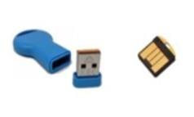

This guide will help you through the onetime setup process to register your security keys. You’ll use your security key daily to access the Amazon network.

2 security keys were sent to you in the mail. They look like this:

1 of these keys will be your primary security key, and the second key is a backup.

***Note****: You must complete this process using a* ***personal Windows or Mac computer*** *and either Google Chrome or Mozilla Firefox. It won’t work on a tablet or mobile device.*

1. 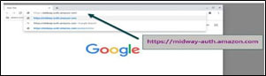Go to [https://midway-auth.amazon.com](https://midway-auth.amazon.com/)
2. Enter your Amazon login information into the Sign in with Midway prompt.
   * 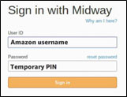Your User ID is your Amazon alias—the part of your Amazon email address that comes before the @. For example, if your email address is [johnsmith@amazon.com](mailto:johnsmith@amazon.com), your alias would be johnsmith.
   * Enter the temporary Midway pin that was emailed to your personal email address or that your manager provided to you.
   * Click **Sign in**.
3. You’ll receive a welcome message that says, “Welcome [your Amazon alias]!” Proceed to the next step.
4. Go to <https://midway.amazon.com/>
5. 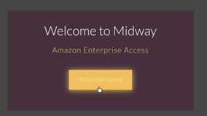On the page that says, “Welcome to Midway,” click the **Register Token** button. Token is a term that’s occasionally used to refer to your security key. They mean the same thing in this case.

* + 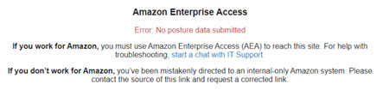If you receive an error message that says, “Error: No posture data submitted,” copy and paste the link from step 4 into an [incognito tab in Chrome](https://support.google.com/chrome/answer/95464?co=GENIE.Platform%3DAndroid&hl=en) or a private window in Firefox. If this error message appears again, ask your manager to resend the temporary Midway password and ask them to verify that both boxes in the password creation tool are checked before they resend.

1. On the page that says, “Get started with Midway,” click the **Begin registration** button.

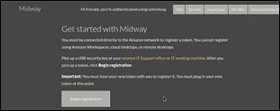

1. 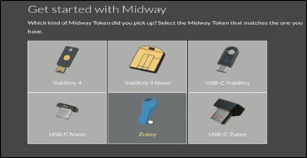Select the image that matches the security key you were sent.
2. Plug 1 security key into an open USB port on your computer. Make sure the USB port does not have a lightning bolt image next to it. These are charging ports and should not be used with security keys.
3. 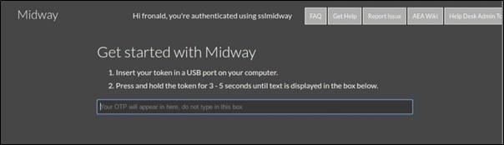Click the empty text box so your cursor appears there. **Don’t type anything**.
4. Press your finger against the security key that’s plugged into your computer and hold it there for 3-5 seconds until text appears within the empty text box.
   * Depending on the kind of security key you have, you may need to press your finger against its side or against its top.
5. On the next screen, you’ll set your Midway pin—which may also be referred to as your Midway password. Type a pin into the **New PIN** field. This Midway pin must be different than your Amazon password, and be easy to remember as you’ll enter it every day when you log in to the Amazon network.
6. 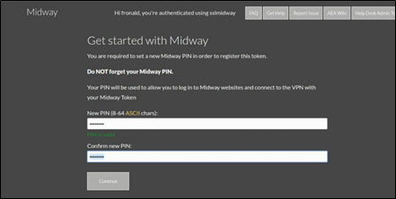Type your new Midway pin again in the **Confirm new PIN** field.
7. Click **Continue**.
8. 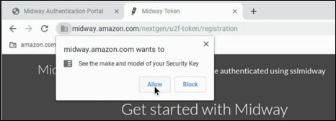On the screen that says, “Get started with Midway. Last step, you’re almost done!” press and hold your finger against your security key again. You may get a pop-up requesting info about your security key. Click **Allow**.

1. 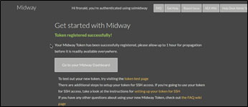Click the **Go to your Midway Dashboard** button.
2. 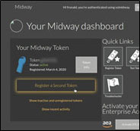Click **Register a Second Token**.

1. 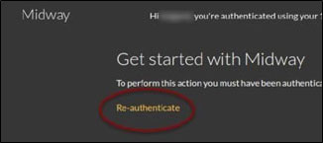Click **Re-authenticate**.
2. Sign in with your User ID—your Amazon alias—and the Midway password that you set in step 11. Don’t use your temporary Midway pin as it will no longer work.
3. Remove the security key from your computer and insert the backup security key.
4. Click the empty text box so your cursor appears there. **Don’t type anything**
5. Press your finger against the security key that’s plugged into your computer and hold it there for 3-5 seconds until text appears in the empty text box.
   * Depending on the kind of security key you have, you may need to press your finger against its side or against its top.
6. On the screen that says, “Get started with Midway. Last step, you’re almost done!” press and hold your security key again. You may get a pop-up requesting info about your security key. Click **Allow**.
7. Click the **Go to your Midway Dashboard** button.
8. You’ve successfully registered your security keys. To log in to the Amazon network going forward, you’ll type your Midway password and then press and hold your security key.

This completes task 1. You can move to task 2.

Task 2: Set up your computer

**There are 2 sets of directions to set up your computer, but you only need to follow 1 set on Day 1. Read the two options below to understand which set of directions to follow.**

* + 1. **Amazon WorkSpace** – Follow these instructions if you **did not** receive an Amazon laptop on Day 1.
       - This is the standard option most new hires will use.
  + Your Amazon WorkSpace is a cloud-based version of your Amazon laptop that runs on your personal computer. It’ll enable you to get started onboarding on Day 1. An Amazon laptop will be shipped to you during your first week.
  + Once your Amazon laptop arrives, you will need to follow the Set up your Amazon laptop directions.

1. **Amazon laptop** – Follow these instructions if you **did** receive an Amazon laptop.

## **Set up your computer with Amazon Workspaces**

## Follow these directions if you did not receive an Amazon laptop on Day 1. If you received an Amazon laptop, follow directions found here.

1. On your personal computer, open a web browser and go to [https://clients.amazonworkspaces.com](https://clients.amazonworkspaces.com/).
2. 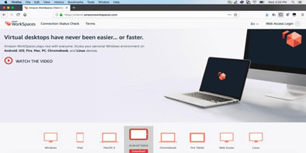Select your personal computer’s operating system and follow the download instructions to install WorkSpaces.
3. 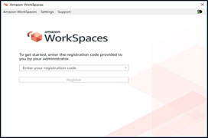After installation, open WorkSpaces > Enter the registration code your manager provided verbally to you during your orientation call > Click **Register**.

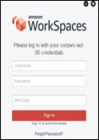

* + If a login prompt doesn’t appear, you might be experiencing an Internet connectivity issue. You can either check your Internet health using [Speed Test](https://www.speedtest.net/), or [contact IT Support](http://firstaid.amazon.com/) for help.

1. When the login prompt appears, plug in your primary security key—the security key you registered first—and enter your Amazon alias in the **Username** field. Enter the temporary Amazon password that your manager shared verbally with you during your orientation call in the **Password** field. Remember, this password is different than your Midway pin.
2. In the **MFA Code** field, enter your Midway pin and then press and hold your security key until a long string of numbers and letters completes your password and signs you in.
3. 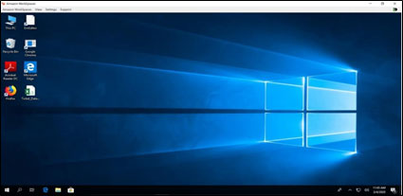Your virtual desktop should appear.

**NOTE: Once your Amazon laptop arrives, you will need to follow the** **Set up your Amazon laptop directions** **to set it up.**

Please note the following about your Amazon WorkSpace:

* If you ever need to access the registration code, visit [the WorkSpaces portal](https://workspaces.amazon.com/).
* Don’t access restricted data or information while using Amazon WorkSpaces with your personal computer. If you’d like additional guidance about what this means, please reach out to your manager.
* [Contact IT Support](https://it.amazon.com/chat) if you need help with your WorkSpace.
* Dive deep on what you can do with your WorkSpace with these it.amazon.com articles: [Corporate WorkSpaces](https://it.amazon.com/en/servicecatalog/corporate-workspaces) and [InfoSec Guidance for Corporate Workspaces](https://it.amazon.com/en/help/articles/infosec-guidance-for-corporate-workspaces%20).

This completes task 2 if you have a WorkSpace. You can move to task 3.

## **Set up your Amazon laptop - Follow these directions if you received an Amazon laptop.**

**Windows laptop directions** (access MacBook directions here)

1. Connect your Amazon laptop to power and turn it on.
2. Insert the primary security key you registered in Step 1.
3. 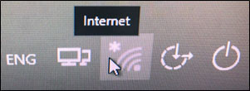From the login screen, click the WiFi symbol and connect to your home internet network.
   * If you have trouble with this step, you may need to connect your laptop directly to your router with an ethernet cable. After this, the wireless connection option should be available.
4. 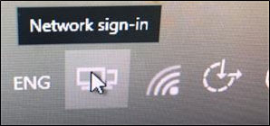Next, you’ll need to connect to the Amazon network. Click the Network sign-in symbol that looks like two monitors and appears next to the WiFi symbol.
5. The Cisco AnyConnect Secure Mobility Client icon should appear. It looks like a circle with round intersecting blue and green lines. Click **Connect**.  
   
6. 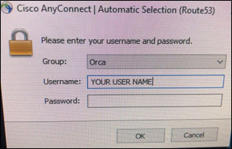The Cisco AnyConnect login box will appear. Type in your username which is your Amazon alias—the part of your Amazon email address that comes before the @.
7. In the password, type in the Midway pin you set while you were registering your USB security keys in Step 1. **IMPORTANT**: Immediately after you’ve typed your Midway pin, press your finger against the USB security key you inserted into your laptop until the rest of your password is filled out. When the Cisco AnyConnect Secure Mobility Client begins connecting you to the network, you can remove your finger.
8. 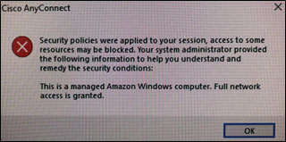If a security notification appears onscreen, click **OK**.
9. 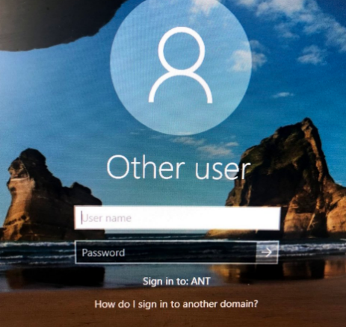You should now see the Windows login screen.
10. Enter your Amazon alias for username. This is the portion of your Amazon email address that comes before the @ sign. This is also described as your Amazon login or username. Alias, login, and username all refer to this same thing.
11. Enter your temporary Amazon password. This is the password your hiring manager provided to you over the phone during your orientation call. This is different than your Midway pin.

This completes task 2 of setting up a Windows computer. You can move to task 3.

**MacBook laptop directions** (access Windows directions here)

**IMPORTANT: If you don’t finish the setup process listed below, you will be locked out of the machine and require a re-image. Please contact IT at** [**it.amazon.com**](http://it.amazon.com/chat) **if you run into any issues.**

1. Connect your Amazon laptop to power and turn it on.
2. Insert the primary security key you registered in Task 1.
3. Select **tokenadmin** from the startup screen and enter the **MacBook network password** your manager provided during your Day 1 call.

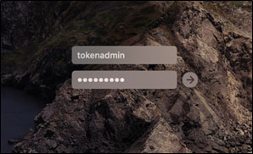

1. If you get a second login, enter tokenadmin and the MacBook network password again.
2. 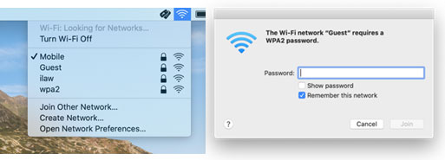Click the WiFi symbol at the top right of your screen and connect to your home internet network.

1. Click the Spotlight icon (Spyglass) at the top right corner of your screen and search for **Cisco**.  
   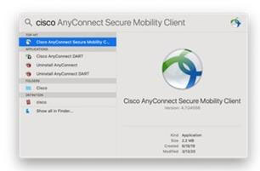
2. Open Cisco AnyConnect Secure Mobility Client. Click **Connect**.  
   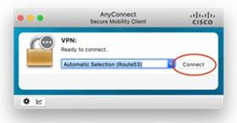
3. Your username is your Amazon alias—the part of your Amazon email address that comes before the @.
4. 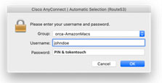In the password field, type in the Midway pin you set while you were registering your security keys in Task 1. **IMPORTANT**: Immediately after you’ve typed your Midway pin, press and hold your finger against the security key you inserted into your laptop until the rest of your password is filled out. When the Cisco AnyConnect Secure Mobility Client begins connecting you to the network, you can remove your finger.
5. 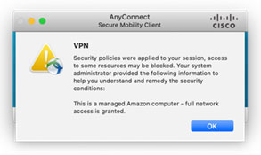You’ll see a security notification when you’re successfully connected. Click **OK**.
6. You’ll receive a prompt to obtain a Kerberos ticket. Move it to the edge of the screen but **don’t** click cancel.  
   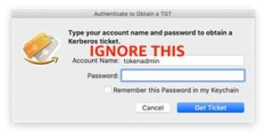

1. Change your temporary Amazon password using [the Amazon Password tool](https://password-v2.corp.amazon.com/). Follow the steps in the tool to complete the process.
   * If you receive an error during this process, check the password requirements and try again.
2. 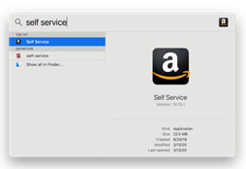Click the Spotlight icon at the top right and search for **Self Service**.

1. 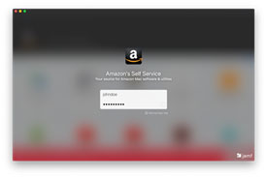When Self Service opens, login with your Amazon alias and the Amazon password you just set.
2. 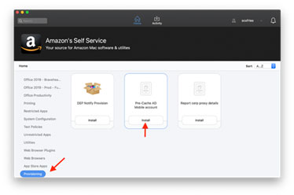Click **Provisioning** from the menu on the left > Install **Pre-cache AD Mobile account**.

1. When prompted, enter your Amazon alias and the Amazon password you just set.
2. The Install button for **Pre-cache AD Mobile account** will change to Reinstall when this process is complete.
3. Restart your MacBook by clicking the **Apple** menu and select **Restart**.
4. At the login screen, select your Amazon alias and enter your Amazon password.
5. 2 prompts will appear: 1 to create a User certificate, and 1 to open a kerberos ticket. Ignore these for now. Move them aside if needed. We will come back to these prompts in steps 22 and 23.
6. Open Cisco AnyConnect, enter your Midway pin, then press and hold your security key as described in Step 7-9 above.
7. Once you are successfully connected to the Amazon network, enter your Amazon **password** in the kerberos prompt, and check the box to **remember the password**.

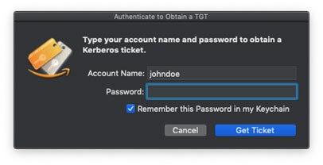

1. In the **User Certificate** window, click **Create**. After a moment, you should receive a message that the certificate was created successfully. Click **OK**.

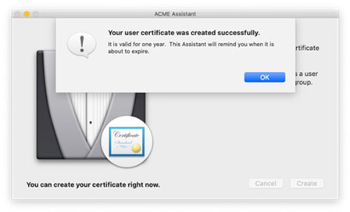

This completes task 2 of setting up a MacBook. You can move to task 3.

Task 3: Set up your software and tools

1. If you haven’t already, change your temporary Amazon password using [the Amazon Password tool](https://password-v2.corp.amazon.com/).
2. To set up your email, instant messaging, and more, follow the instructions in the [Get started as a new hire](https://it.amazon.com/en/help/articles/set-up-your-computer-as-a-new-hire) article on it.amazon.com.
   * **Pro tip:** [it.amazon.com](http://it.amazon.com) has hundreds of self-serve IT help articles and IT support contact information. It’s a great place to start if you have an IT issue or question.

This completes your IT setup.

Need help? [Contact IT](http://it.amazon.com/chat) at [it.amazon.com](http://it.amazon.com) from any internet browser.

**FAQs:**

**I haven’t received my USB Security Key. What should I do?**

Reach out to your manager and let them know so they can order a replacement for you as soon as possible.

**I need help to complete these steps. What should I do?**

Please reach out to IT by visiting [it.amazon.com](http://it.amazon.com/chat). You will need to answer a few security questions to verify your identity.

**Do I always need to connect to the Amazon network (VPN) before I login to my device?**

Going forward, you will log into your device with your alias and Amazon password. If you are not working in an Amazon building, you will need to connect to VPN as well.

**How do I connect to VPN after I login?**

1. Open **Cisco AnyConnect Secure Mobility Client.**
   * Open **Start Menu** > Type and select **Cisco AnyConnect Secure Mobility Client.**
2. In the **Cisco AnyConnect** window, the drop-down menu should say **Automatic Selection (Route 53).**
3. Click **Connect** > Cisco will open a window asking for your VPN credentials:
   * **Group**: This will automatically populate depending on your operating system.
   * **Username**: Enter your Amazon aliaswithout @amazon.com.
   * **Password**: Enter your Midway PIN then place your finger on the side or top of your **security key** until a series of “*” appear. The Cisco AnyConnect Mobility Client will then attempt to connect to the Amazon Network.
4. You will see the below image confirming you are connected to the Amazon network over VPN.
   * VPN sessions time out every 12 hours and then require re-authentication.

# 

# 

# **Do I need to be connected to the Amazon network to do my job?**

To access internal Amazon tools and services, you will need to authenticate yourself using your security key daily.